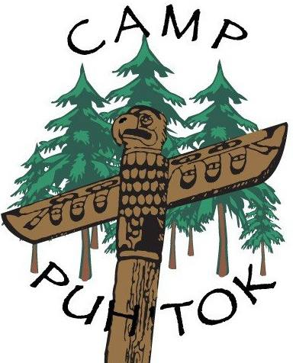

**General Expectations on Field Trips**

Camp Puh’Tok is hosting several Environmental Education Programs! The trips will be **first come, first serve**. Please reach out if you are interested in signing up!

The program will require a minimum of 4 teachers and/or chaperones per 100 children. The class will be divided into max group sizes of 25 students and will require one teacher/chaperone per group.

I am available for registration and questions via email at [eczaplicki25@gmail.com](mailto:eczaplicki25@gmail.com), I can also be reached through the camp office at (410) 329- 6590 or fax (410) 329- 6034.

**THANK YOU** for your time and consideration, I look forward to working with your students! Please find included a list of teacher/chaperone expectations, what to bring, and a camp map.

-------------------------------------------------------------------------------------------------------------------------------

|  |  |
| --- | --- |
| **What is Expected of Teacher and Chaperones** | **What Do I Need To Bring** |
| * Help facilitate educational lessons | * Appropriate clothing for weather- rain or shine |
| * Monitor & guide group to and from stations | * Any prescribed medications |
| * Keep student focus on lesson and wildlife | * Camera (optional) |
| * Discourage social talking and phone use | * Sturdy closed-toe shoes |
| * Remind everyone to stay on trails | * Water bottle |
| * Share enthusiasm for discovering nature | * Packed lunch |
| * Watch and assist all children in group |  |

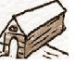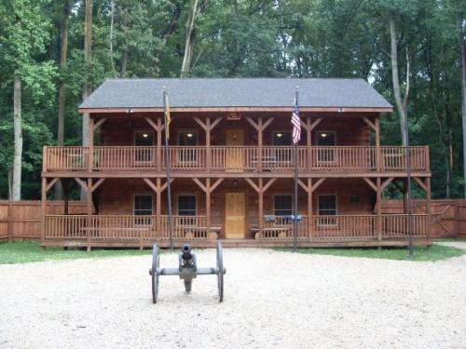

**Field**

**The Glen**



**To I-83**

**3**

**1**

**6**

**7**

**8**

**18**

**11**

**12**

**13**

**14**

**15**

**24**

**21**

**2**

**5**

**9**

1. Camp Puh’Tok Entrance
2. Covered Bridge
3. The Glen
4. Hacienda & Pool
5. Frog Hollow
6. Tlingit Lodge
7. Yukon Lodge
8. Denali Lodge
9. Top Bar Ranch
10. Camp Office
11. South Platte
12. Chimney Rock
13. Scott’s Bluff
14. Sweetwater Station
15. Willamette Valley
16. Nurse’s Lodge
17. Trading Post
18. Thunderbird Lodge
19. Nature Lodge
20. Homestead
21. The Pueblo
22. The Council Ring
23. The Hogan
24. Fort Mackinac

**Fort Mackinac**

**Alaskan**

**Village**

**Indian Village**

**Pioneer**

**Village**



**17433 Big Falls Rd.**



**Field**



**To Big**

**Falls Rd.**

**4**

**10**

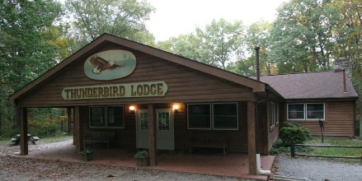

**Top Bar Ranch**

Welcome

to

Camp Puh’tok

**19**



**16**



**17**



**23**

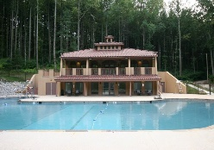

**20**

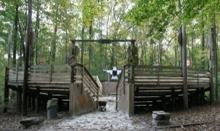

**22**

**Office**

